Swim

Swim through the water and avoid dangerous predators

### Gameplay Overview

**Description:** You play a stingray who constantly swims forward through the ocean. Coming in the opposite direction is different sea predators that you must avoid. You can shoot down the predators with bullets made of magical energy the ocean gods gave you. Occasionally, some of the predators will drop power-ups or different types of bullets. The longer you survive, the more predators come your way at faster speeds.

**Win condition:** None, you only aim to survive.

**Lose condition:** Three lives, hitting the sides of the reef or being hit by a predator will cause you to lose one. Lose all three and you die.

### Controls

**Left:** Move left

**Right:** Move right.

**A:**  Shoot a bullet.

**Start:** Pause game.

### Audio

* Menu music: something upbeat and ocean-y or <https://www.youtube.com/watch?v=acibVFWo0UA>
* Game music: chill song, like in those lo-fi radios on YouTube
* Pause music: chill song continues
* Shooting bullets: screaming
* Hitting the sides of the reef or being hit by a predator: <https://www.youtube.com/watch?v=31g0YE61PLQ>
* Killing a predator: kill sound?
* Lose: Sad music

### Gameplay Details

**Shooting:** Shooting uses ammo, and ammo is going to be similar to bullets used in Mode 4 games. A struct of bullets (sprites?), have a max amount visible on screen at a time. Bullets change with a power up dropped by a predator

**Predators and Difficulty:** Have 2 types of predators (sprites). Initially, you’ll only see the first predator coming towards you and as you go on in the game, the second one will appear and both will begin to appear with greater frequency to increase the difficulty. The second predator will require 2 bullets to kill it.

Maybe just have the first predator only and change the color of it for the second predator (like white sharks, then black sharks)

ALSO after both appear, increase the speed of the predators coming for more difficulty?

**Cheat:** the powerups dropped by some of the predators and these powerups only available after you’ve gotten far enough that the second predators are appearing, if you pick it up then your bullet type will change, and when it changes, you can kill a second predator with one of the power-up bullets. Only available for like 5 seconds though.

Can maybe use the same bullets, give it a variable for whether it’s a powered up one or not. Check for if it’s powered up or not each time a collision is met.

Maybe have a cheat that removes all the predators currently on the screen.

Do these count as cheats.

**Backgrounds**: Two simultaneous backgrounds are going to be a front slow moving reef on either side of the screen and a faster moving ocean water behind the reefs.

**Lives:** when you lose a life, have the stingray flash like red for a second and decrement the lives display in the bottom corner.

Flashing too much work?

### Illustrations

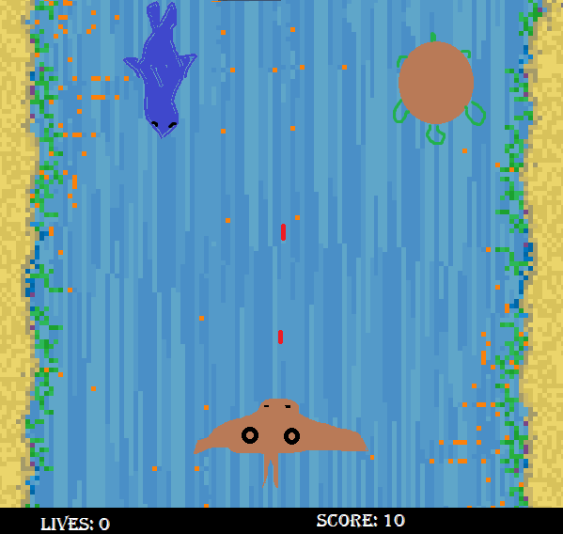

Stingray at bottom swimming up, shooting red bullets, and avoiding the shark and the turtle coming down.

Enemy 1 rdel (speed going down) will be 1

Enemy 2 rdel = 2

Enemy 3 rdel = 3

|  |  |  |  |
| --- | --- | --- | --- |
|  | rDel (speed) | Color | Number |
| Enemy1 | 1 | Red |  |
| Enemy2 | 2 | Yellow |  |
| Enemy3 | 3 | Blue |  |